Instructor Martin Campos
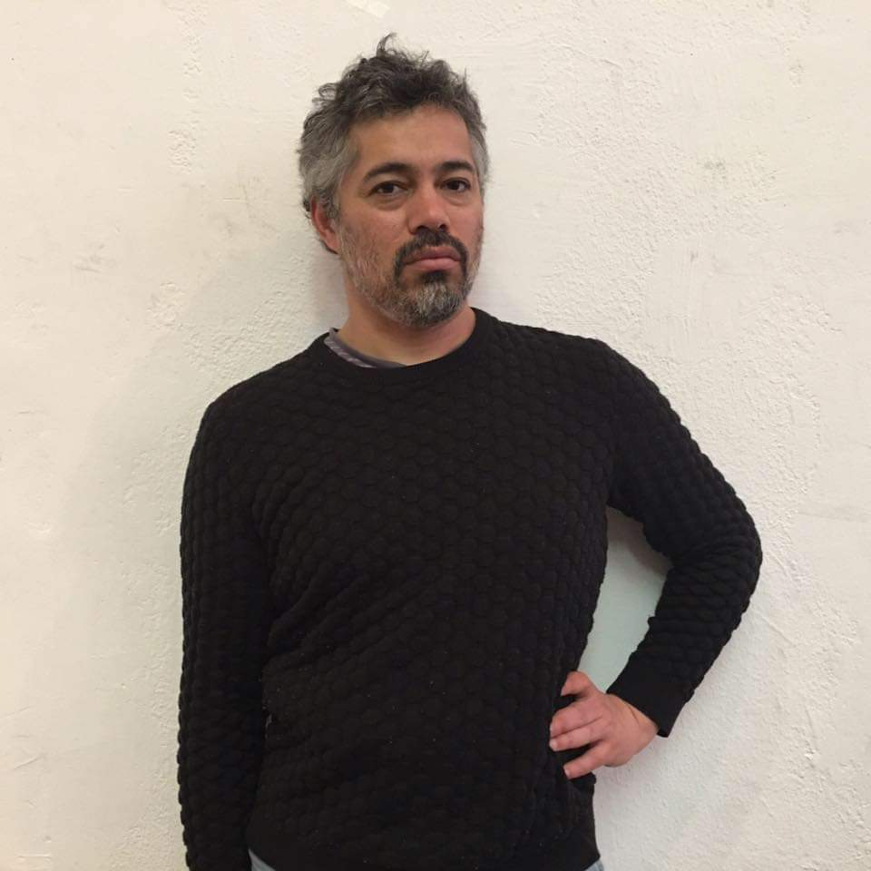
Arcenio Martin Campos attended New Mexico State University for studio arts, the University of New Mexico for art history, and received a Certificate of Painting from the Pennsylvania Academy of Fine Arts. He began drawing on his own as a child, and between schools acquired much of his fine art education from independent study and private instruction. Mr. Campos began his teaching career conducting classes in cast drawing whilst still in New Mexico. He has given lectures on anatomy, figure drawing, and painting., as well as workshops on painting the landscape. His work has received numerous awards and has been exhibited throughout the United States and abroad.
Mr. Campos currently teaches at the Pennsylvania Academy of Fine Arts, Fleisher Art Memorial, the Washington Studio School, and the Wayne Art Center.
He has conducted workshops abroad in Spain, Ireland, South Africa and New Zealand and in 2018 in Provence with Lavender and Vine.

