PAINTING IN PROVENCE, FRANCE
INSTRUCTION BY KURT SCHWARZ
SEPTEMBER 4-12, 2020

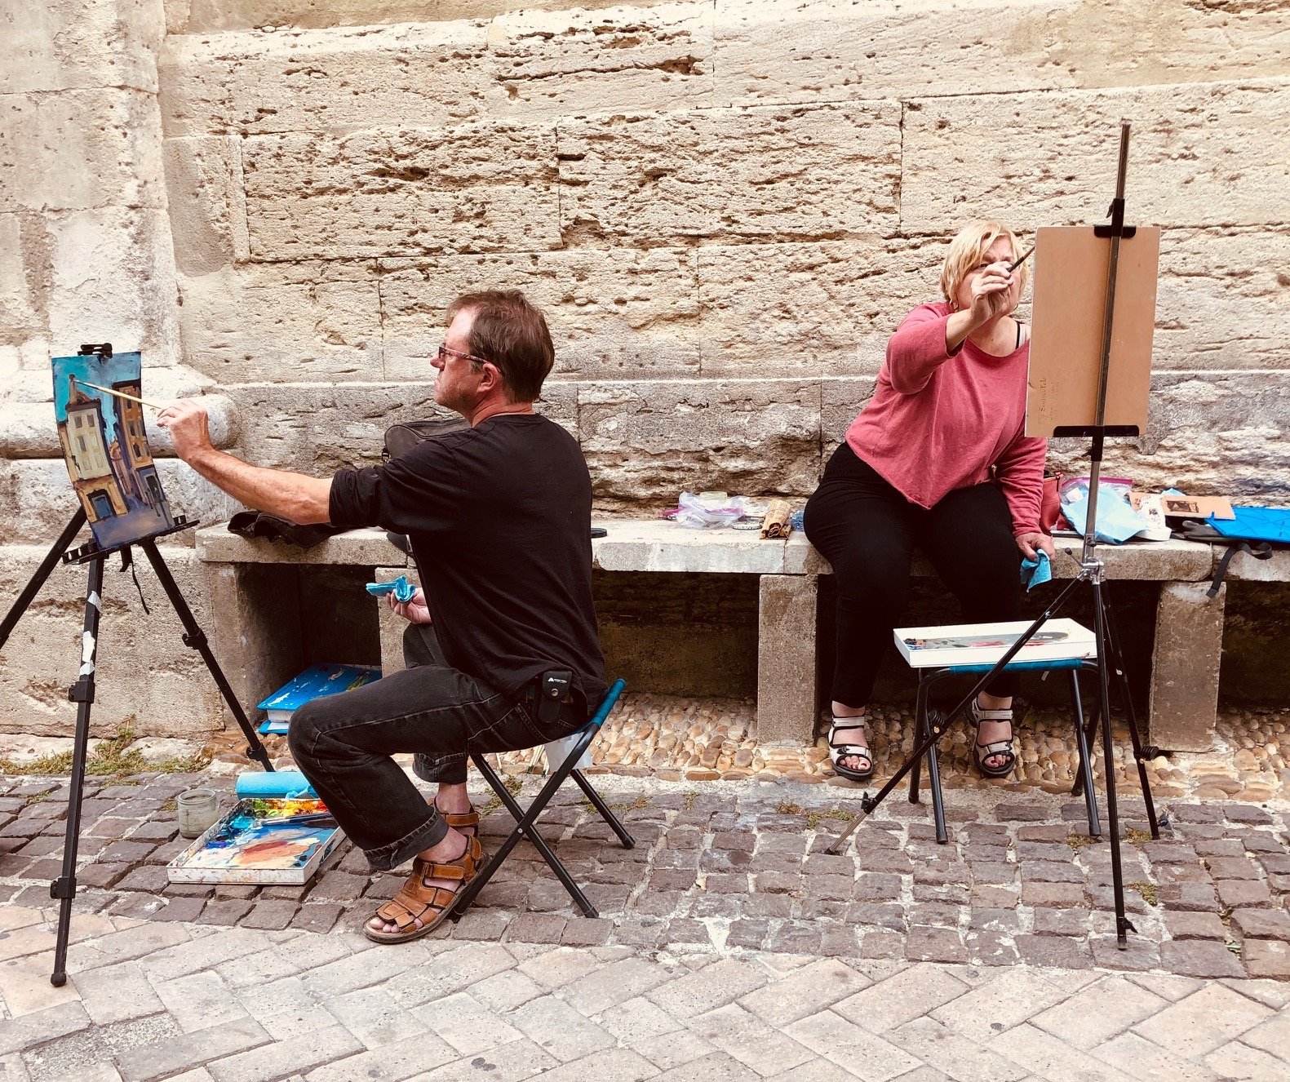
Why did so many famous painters gravitate towards the South of France? Come with us this fall to witness the light and colors of Provence. Van Gogh, Cezanne and so many others discovered the magic of Provence and now we invite you to join us for a small group experience, “Painting in Provence” with instructor Kurt Schwarz.*

The base of our operation will be a villa in a small village near Orange. We will have daily excursions from here, so you can unpack and make yourself at home for the week here in the charming village of St. Cécile-les-Vignes, France.

Fall is a great time of the year to paint in Provence during the annual wine harvest, when we have sunny days to paint outdoors, and the heat of summer is over. The markets and activities continue, but the tourists are back at work and or school.

“Plein air” and studio painting will be available with instruction from Kurt Schwarz. We plan to have full days of painting and alternate days of sightseeing. You can of course sketch or paint on the sightseeing days as well if you choose.

Our friends at Rouge Bleu winery will be in full harvest mode at this time, and have graciously invited us to tour and taste at their winery, on the beautiful terrace with vistas of the “Dentelles de Montmirail” mountains as a backdrop. We will paint one day in one of the famous wine towns perched on these mountains!

One day we will visit St. Rémy-de-Provence and the nearby asylum where Van Gogh spent only 1 year yet painted over 150 works in that period. There will be time here to sketch but also much inspiration to take back with us. In nearby les Baux we will see a one-of-a-kind multimedia show . The show is an animated presentation, set to music and projected in an old quarry! This show is hard to describe, but also hard to forget!

The markets of Provence are a feast for the senses. From the bright colors of the local produce, live music and the scents of open air street food, you will enjoy 2 markets during your week in Provence! One in our own little village, a 10 minute stroll from the villa and another in the village of Vaison la Romaine.

The village is named (la Romaine) because the Romans have quite a history here and many ruins throughout the village remain. Stroll the market and cross over a Roman Bridge (still in use) to the medieval part of the city where meandering streets and sidewalks, arches and terraces wind their way up to an old Fort.

We have a few new sights in store this year to be announced soon!
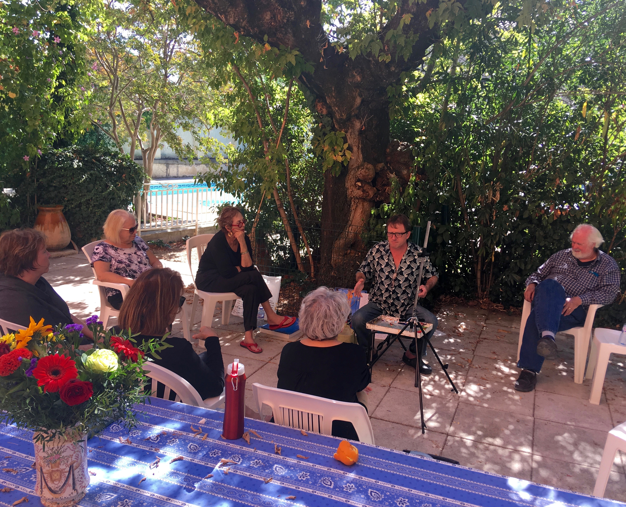
$2995 per person double occupancy. Maximum of 12 in the group.

PRICE INCLUDES; Lodging in private villa with pool, daily breakfast, 4 lunches, 3 dinners (including wine), Marseille airport and Avignon train transfers, all excursion transport, entrance fees, art instruction with Kurt Schwarz* and Josie Beth Vosoba, experienced guide and translator. (International airfare is not included in the tour price).

*Read more about Kurt Schwarz on the “Available Tours” page link. Kurt has led painting workshops in Italy for many years and did this tour in Provence in 2018.

Beth Vosoba is the tour organizer and has been leading tours to Provence and staying in this villa for more than 10 years.

